

Home Page = index.html 

Fig 1. Welcome Page With The Navbar & Attractive Image Of Nature With Animals Indicates The Wildlife National Parks

When The Site Opens The Welcoming Image & Navbar To Attract More To Explore The Website To Get The Information From The National Parks Info Website

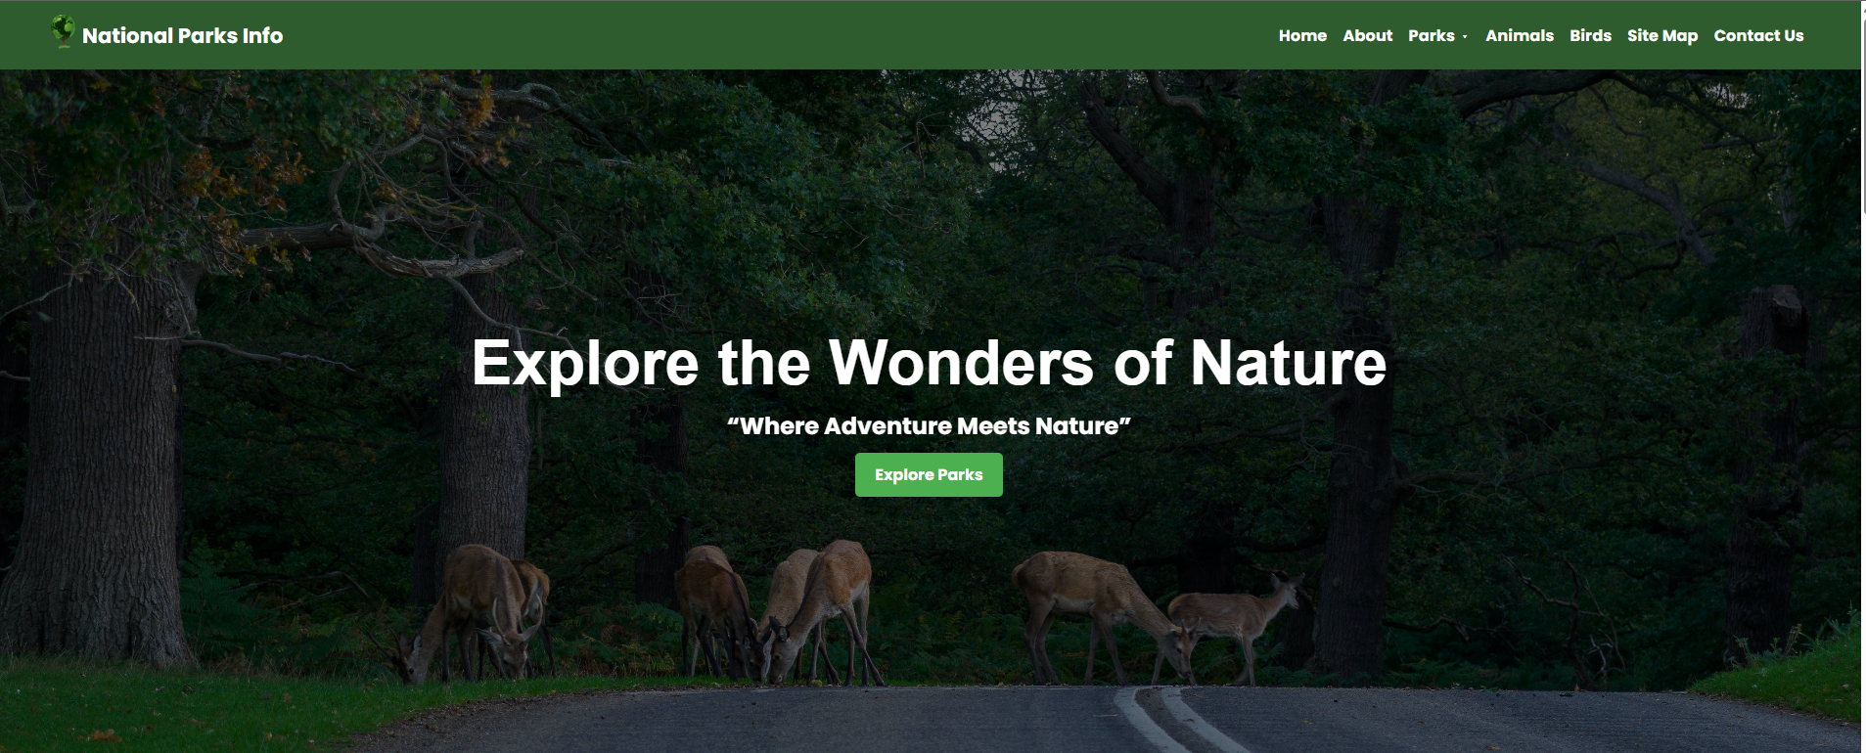

This Is The Welcoming Website Attraction To Explore More Information About The Nature & Wildlife .

Fig 2: Home Page Frame Interface